What you need to know about Plato
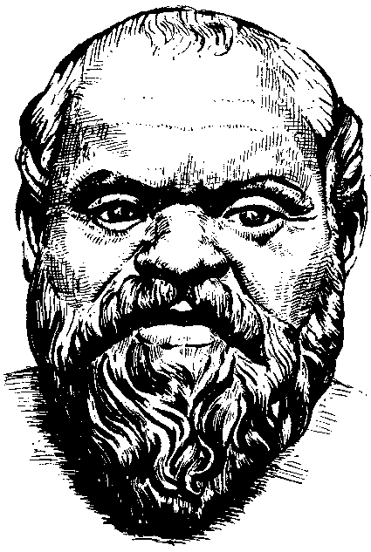
There are three main things that you need to know in order for you to fully understand Plato and his World of Forms:

- His beliefs about the physical world
- The influence of Socrates
- The influence of Heraclitus.

Below is a brief outline of each:

- Plato believed, as all Ancient Greeks did, that the world was formed from pre-existing matter. His reasoning process led him to believe that all matter was inherently evil as it could contain no real truth or knowledge of the universe. This is because matter is in a constant state of flux.
- Socrates was Plato’s teacher. He was searching for truth through questioning. Socrates believed that when we asked the question ‘What is it that makes something ‘x’ or ‘y’ (Beautiful, Just or Good for example)?’ that we would only get a partial explanation. This indicated that the answers to these types of questions did not exist in this realm but in another realm.
Task - In pairs try to answer the following questions to see if you can prove Socrates wrong:
a) What is it that makes something Beautiful?
b) What is it that makes someone a good friend?
c) What is it that makes a good community?
- Heraclitus was a pre-Socratic philosopher who came up with a doctrine about the things or objects in the universe: ‘Something is no more ‘X’ than it is ‘Y’.
Task – Ask yourself the following questions to help you understand what Heraclitus meant:
a) Do you consider yourself short or tall?
b) List as many things as you can that are shorter or taller than you are.
c) Then ask yourself whether it truly makes sense to claim that you are short or tall when so many things are taller or shorter than you are.

Heracliteanism states that is does not make any sense to claim that something is more ‘X’ than it is ‘Y’ because there are so many examples which would claim otherwise.

Plato’s conclusion: Plato combines all 3 elements above and concludes that True knowledge cannot exist in a world which is: in a state of flux; inherently evil; and unable to provide full answers to the ‘What is it?’ questions. He therefore concludes that TRUE knowledge must exist in a non-physical realm that is immutable and eternal. This is Plato’s World of Forms.

