**Wedge Issue: Gun Ownership**

* **What events have highlighted issues around gun ownership?**
* **What are the key arguments around this issue?**
* **How does this issue divide US society?**
* **How does this issue divide political parties?**
* **How do states divide on the issue of gun ownership?**



**Wedge Issue: Gay Marriage**

* **What are the key arguments around this issue?**
* **How does this issue divide US society?**
* **How do politicians react to this issue?**
* **How do states divide on the issue of gay marriage?**
* 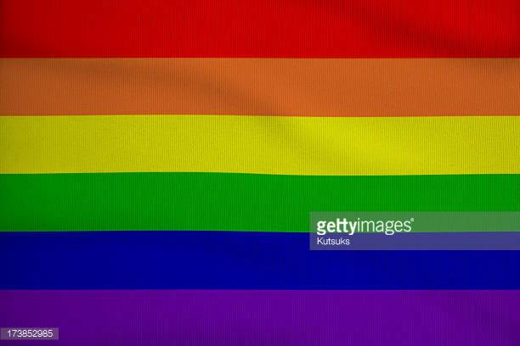**What role have propositions played in the issue of gay marriage?**

**Wedge Issue: Abortion**

* **What events have highlighted issues around abortion?**
* **What are the key arguments around this issue?**
* **How does this issue divide US society?**
* **How does this issue divide political parties?**
* 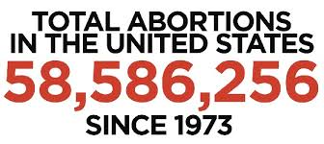**How do states divide on the issue of abortion?**

**Wedges Issue: Death Penalty**

* **What are the key arguments around this issue?**
* **How does this issue divide US society?**
* **How do politicians react to this issue?**
* **How do states divide on the issue of the death penalty?**
* **Is the death penalty constitutional?**

**Wedge Issue: Immigration**

* **What are the key arguments around this issue?**
* **How does this issue divide US society?**
* **How do politicians react to this issue?**
* **How do political parties divide on the issue of immigration?**
* 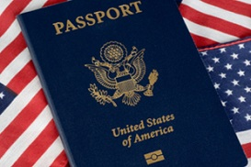**Explain the key immigration issues in the 2016 presidential election.**

**Wedge Issue: Free Speech**

* **What events have highlighted issues around free speech and hate speech?**
* **What are the key arguments around this issue?**
* **How does this issue divide US society?**
* **Is free speech always constitutional?**
* 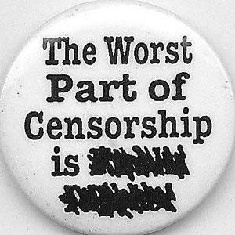**What impact does this issue have on religious freedom?**