**Introduction to Political Parties (Independent Study Booklet)**

***Unit 3C: Political Processes in the USA- Miss Christian***



**Key Questions:**

* How have political parties changed over time?
* What are the values and policies of the Democratic Party?
* What are the values and policies of the Republican Party?
* How similar and different are the two main political parties?
* How divided are the Republicans?
* How divided are the Democrats?
* Who votes Republican, and why?
* Who votes Democrat, and why?

**Learning Outcomes:**

**By the end of this project you will be able…**

* To explain the transformation of the two major parties from broad non-ideological coalitions in the 1950s and 60s into more ideologically cohesive parties of today
* To explain the core values of the political parties
* To analyse the extent to which the policies of the political parties reflect their values
* To identify similarities and differences between the political parties
* To explain the effect of these similarities and differences on the political system
* To identify the different groups of voters who typically support each party
* To explain historic and contemporary reasons for this support
* To assess the relative significance of different groups to the parties
* To explain the current ideological divisions between factions within the political parties
* To examine the values, influence and success of the different factions within each party

# party_democratThe Democratic Donkey and the Republican Elephant

Ever wondered what the story was behind these two famous party animals?

The now-famous **Democratic donkey** was first associated with Democrat Andrew Jackson's 1828 presidential campaign. His opponents called him a jackass (a donkey), and Jackson decided to use the image of the strong-willed animal on his campaign posters. Later, cartoonist Thomas Nast used the Democratic donkey in newspaper cartoons and made the symbol famous.

|  |
| --- |
| party_republican |

Nast invented another famous symbol—the **Republican elephant**. In a cartoon that appeared in *Harper's Weekly* in 1874, Nast drew a donkey clothed in lion's skin, scaring away all the animals at the zoo. One of those animals, the elephant, was labeled “The Republican Vote.” That's all it took for the elephant to become associated with the Republican Party.

Democrats today say the donkey is smart and brave, while Republicans say the elephant is strong and dignified.

# Introduction

# Image result for how have political parties changed

# Image result for watch video

# Watch the video: [Political Parties: Crash Course Government and Politics #40](https://www.youtube.com/watch?v=VEmOUHxessE)

**How have political parties changed over time?**

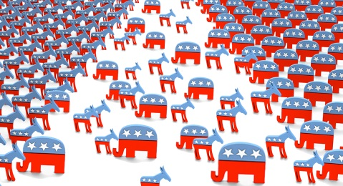

**Reading and Note Taking**: Political Parties and the Party System (Singh p 46-50)

*[Type your notes here…]*

**Reading and Note Taking**: American Political Parties in transition (McKay p86-108)

*[Type your notes here…]*

|  |  |  |
| --- | --- | --- |
| **Time** | **Democrats** | **Republicans** |
| Watch the video: [From White Supremacy to Barack Obama – story of the Democratic Party](https://www.youtube.com/watch?v=Z6R0NvVr164) | Watch the video: [How the Republican Party went from Lincoln to Trump](https://www.youtube.com/watch?v=s8VOM8ET1WU) |
| **Origins 18th century – early 20th century** | Key Ideas:  *[Type your notes here…]*  Support: *[Type your notes here…]*  Success:  *[Type your notes here…]* | Key Ideas:  *[Type your notes here…]*  Support: *[Type your notes here…]*  Success:  *[Type your notes here…]* |
| **Early 20th Century** | Key Ideas:  *[Type your notes here…]*  Support: *[Type your notes here…]*  Success:  *[Type your notes here…]* | Key Ideas:  *[Type your notes here…]*  Support: *[Type your notes here…]*  Success:  *[Type your notes here…]* |
| **1930s – 1950s** | Key Ideas:  *[Type your notes here…]*  Support: *[Type your notes here…]*  Success:  *[Type your notes here…]* | Key Ideas:  *[Type your notes here…]*  Support: *[Type your notes here…]*  Success:  *[Type your notes here…]* |
| **1950s – 1960s** | Key Ideas:  *[Type your notes here…]*  Support: *[Type your notes here…]*  Success:  *[Type your notes here…]* | Key Ideas:  *[Type your notes here…]*  Support: *[Type your notes here…]*  Success:  *[Type your notes here…]* |
| **1960s – 1990s** | Key Ideas:  *[Type your notes here…]*  Support: *[Type your notes here…]*  Success:  *[Type your notes here…]* | Key Ideas:  *[Type your notes here…]*  Support: *[Type your notes here…]*  Success:  *[Type your notes here…]* |
| **1990s** | Key Ideas:  *[Type your notes here…]*  Support: *[Type your notes here…]*  Success:  *[Type your notes here…]* | Key Ideas:  *[Type your notes here…]*  Support: *[Type your notes here…]*  Success:  *[Type your notes here…]* |
| **2000-2008** | Key Ideas:  *[Type your notes here…]*  Support: *[Type your notes here…]*  Success:  *[Type your notes here…]* | Key Ideas:  *[Type your notes here…]*  Support: *[Type your notes here…]*  Success:  *[Type your notes here…]* |
| **2009-2015** | Key Ideas:  *[Type your notes here…]*  Support: *[Type your notes here…]*  Success:  *[Type your notes here…]* | Key Ideas:  *[Type your notes here…]*  Support: *[Type your notes here…]*  Success:  *[Type your notes here…]* |
| **Current Stances**  **(2016 election campaign onwards)** | Key Ideas:  *[Type your notes here…]*  Support: *[Type your notes here…]*  Success:  *[Type your notes here…]* | Key Ideas:  *[Type your notes here…]*  Support: *[Type your notes here…]*  Success:  *[Type your notes here…]* |

*NB: The two main parties occupy a very narrow ideological space. Both are committed to capitalism and constitutional democracy. They are both very flexible and, as history has demonstrated, they have both been prepared to redefine their policy direction when necessary.*

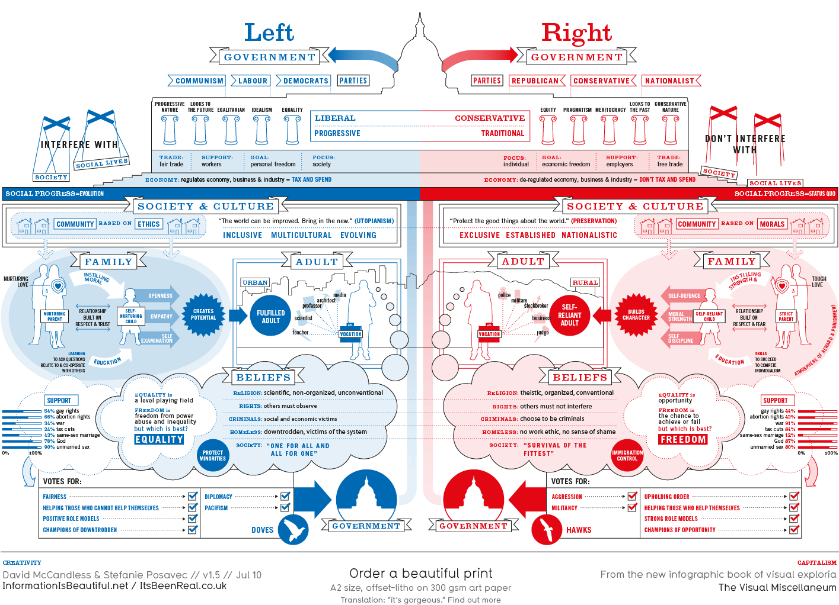**What are the values and policies of the political parties?**



Watch the video: [Political Ideology: Crash Course Government and Politics #35](https://www.youtube.com/watch?v=j_k_k-bHigM&t=88s)

**Reading and Note Taking:** Key Ideas and Principles of the Democratic and Republican Parties (Pearson p419-426)

*[Type your notes here…]*

|  |  |  |
| --- | --- | --- |
| Additional Website: <http://www.diffen.com/difference/Democrat_vs_Republican> | **What are the values and policies of the Democratic Party?** | **What are the values and policies of the Republican Party?** |
| Access the website: <https://www.democrats.org/party-platform> | Access the website: <https://www.gop.com/the-2016-republican-party-platform/> |
| **Philosophy** | *[Type your notes here…]* | *[Type your notes here…]* |
| **Economy** | *[Type your notes here…]* | *[Type your notes here…]* |
| **Society** | *[Type your notes here…]* | *[Type your notes here…]* |
| **Military/Defence** | *[Type your notes here…]* | *[Type your notes here…]* |
| **Gay rights** | *[Type your notes here…]* | *[Type your notes here…]* |
| **Abortion** | *[Type your notes here…]* | *[Type your notes here…]* |
| **Death Penalty** | *[Type your notes here…]* | *[Type your notes here…]* |
| **Taxation** | *[Type your notes here…]* | *[Type your notes here…]* |
| **Government Regulation** | *[Type your notes here…]* | *[Type your notes here…]* |
| **Healthcare** | *[Type your notes here…]* | *[Type your notes here…]* |
| **Minimum Wage** | *[Type your notes here…]* | *[Type your notes here…]* |
| **Foreign Policy** | *[Type your notes here…]* | *[Type your notes here…]* |
| **Civil Rights** | *[Type your notes here…]* | *[Type your notes here…]* |
| **Immigration** | *[Type your notes here…]* | *[Type your notes here…]* |
| **Traditionally strong in states…** | *[Type your notes here…]* | *[Type your notes here…]* |
| **Congressional Leaders** | *[Type your notes here…]* | *[Type your notes here…]* |
| **Seats in House** | *[Type your notes here…]* | *[Type your notes here…]* |
| **Seats in Senate** | *[Type your notes here…]* | *[Type your notes here…]* |
| **Governorships** | *[Type your notes here…]* | *[Type your notes here…]* |
| **Membership** | *[Type your notes here…]* | *[Type your notes here…]* |

**EXAM QUESTIONS:**

**Explain the main values and policies of the Democratic Party. (15)**

*Content Guidance:*

The main values and policies which have become associated with the Democratic Party since the 1960s include:

* ‘big government’ – an extensive federal role in management and regulation of the economy, such as the auto industry ‘bailouts’ of 2009, the Recovery Act 2009, the Dodd-Frank Act 2010, higher fuel emission standards (including the first ever standards for commercial vehicles) 2011, attempt to pass the Clean Energy bill in 2009-10, including a ‘cap and trade’ provision; progressive taxation, such as the ending of the Bush tax cuts for joint incomes over $450,000 in 2013; federal supervision and/or provision of health and education services, such as the ‘Race to the Top’ education program, and the Children’s Health Insurance Authorization Act 2009, expanding CHIP, and the Affordable Care Act 2010; welfare and pensions; the raising of living standards through, for example, minimum wage or equal pay legislation such as the Lilly Ledbetter Fair Pay Act 2009
* social liberalism – promotion of issues such as: gun control, such as the package of measure proposed by President Obama in 2013 after the Newtown shootings; ‘pro -choice’ on abortion, such as the reversal of the ‘Mexico City’ policy 2009; feminism; gay rights, such as the repeal of ‘Don’t Ask, Don’t Tell’ 2010 and the support expressed by the president and vicepresident for gay marriage in 2012; minority rights, such as the Claims Resolution Act 2010 compensating black farmers, the Hate Crimes Prevention Act 2009 expanding the type of groups covered by hate crime legislation, the Fair Sentencing Act 2010 reducing the sentencing disparity between crack and powder cocaine possession, and attempts to pass the Dream Act in 2010 and the subsequent enforcement of some of its measures through executive action
* foreign policy – typically more ‘dovish’ than ‘hawkish’, less assertive exertion of US power, less emphasis on unique US role in the world and a preference for diplomacy over the use of military force, e.g. Obama commitment 2009 to talks ‘without preconditions’ with Iran, ‘reset’ in relationship with Russia, ‘leading from behind’ in action in Libya, withdrawal of troops from Iraq and 2014 deadline for withdrawal from Afghanistan.

**Explain the main values and policies of the Republican Party. (15)**

*Content Guidance:*

Current conservative Republican Party values and policies were largely defined by the presidency of Ronald Reagan 1980-88; Reagan’s emphasis on small government was to some extent diluted by the ‘compassionate conservatism’ of George W Bush, but the small government wing of the party was revived through the influence of the Tea Party movement post-2008.

Main values:

* limited government – tax cuts, reduced government spending; deregulation of business, hostility to expansion of environmental regulation, or government involvement in healthcare; power to the states at expense of the federal government
* social conservatism – pro-life and traditional family values, unsympathetic to rights for alternative lifestyles e.g. same sex marriage, and feminist demands for equal treatment; promotion of gun rights; belief in strong law and order so consequently hostile to ‘amnesty’ for illegal immigrants
* assertive foreign policy – Republicans have become associated with the use of military power to protect American interests abroad and, during the ascendancy of the ‘neo-cons’, with the promotion of democracy through ‘regime change’ in selected dictatorships

**How similar and different are the two main political parties?**

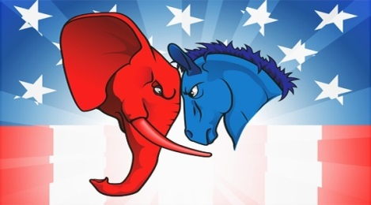

**Reading and note taking:** Polarisation of American politics (Bennett p122-134)

*Similarities between the parties*

*[Type your notes here…]*

*Differences between the parties*

*[Type your notes here…]*

**Reading and note taking:** What do Democrats and Republicans stand for? (Singh p50-61)

*Similarities between the parties*

*[Type your notes here…]*

*Differences between the parties*

*[Type your notes here…]*

**STRETCH & CHALLENGE – Further Reading:** [Big Gulf Between Parties, Divisions Within](https://www.washingtonpost.com/politics/big-gulf-between-parties-divisions-within/2012/08/18/f5ee15d4-e31a-11e1-ae7f-d2a13e249eb2_story.html?utm_term=.f8a9133d1164) (WP Article)

*[Type your notes here…]*

**EXAM QUESTION:**

**‘The two major parties have no significant overlap in ideas and policies.’ Discuss. (45)**

This exam question requires to you to identify the extent of similarities and differences between the two political parties – remember that the “extent” of overlap is the focus of the question and is where you need to show your analysis and evaluation. How could you answer this question? Create an essay plan below to show how you would approach this question.

*[Type your essay plan here…]*

**How divided are the Democrats?**

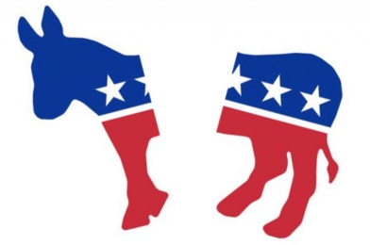

**TASK:** Read the article that argues the Democrats are less divided than in the past.

<https://www.huffingtonpost.com/entry/democratic-party-not-as-divided-as-in-the-past_us_5947a664e4b0d188d028000e>

How convincing is this analysis of the division within the Democrats?

*[Type your notes here…]*

**STRETCH & CHALLENGE TASK:** Read the article that argues the opposite is in fact true.

<https://www.spectator.co.uk/2017/05/the-democrats-divided/>

How convincing is this analysis of the division within the Democrats?

*[Type your notes here…]*

**EXAM QUESTION:**

**How influential are conservatives in the Democratic Party? (15)**

*Content Guidance:*

From the 1960s onwards, the Democratic Party lost progressively more of its traditional Southern conservative base, as it became identified with an increased role for the state in society, and liberal social causes such as minority rights, abortion rights and environmentalism. While there are now almost no ‘pure’ conservatives left, there are still some in the party who do not subscribe to elements of the liberal economic and social agenda.

Evidence which suggests conservatives are not influential in the Democratic Party includes:

* The history of the Clinton presidency – attempted health care reform, Brady bill, veto of partial birth abortion ban bill, defence of affirmative action (‘mend it don’t end it’)
* ‘Six for 06’ agenda for the 2006 mid-terms.
* The history so far of the Obama presidency - stimulus package, health care reform, increased regulation of the finance industry.
* The core of the party remains on the left, represented through the current congressional leadership, e.g. Speaker Pelosi, and through the ‘blogosphere’, e.g. websites such as Mother Jones, Firedoglake and Daily Beast, which was active in the defeat of Joe Lieberman in the Connecticut Senate primary in 2006 & the unsuccessful challenge to Blanche Lincoln in the Arkansas Senate primary in 2010.

Evidence which suggests conservatives are influential includes:

* Conservative elements in the Clinton presidency; Clinton was hostile to some liberal causes as governor, e.g. he supported the death penalty, and as president signed the Personal Responsibility and Work Opportunity Act (reforming welfare) and the Defense of Marriage Act.
* The explicit policy of the recruitment of more conservative candidates for the 2006 mid-terms.
* President Obama has initiated a ‘surge’ in Afghanistan, alienating liberals, and has so far disappointed liberals on a number of issues, such as immigration reform, gun control, abortion and the environment.
* The role of the ‘Blue Dogs’ and moderate senators in removing a ‘public option’ from health care reform.
* The role of pro-life Democrats in promoting the Stupak-Pitts Amendment, banning the use of federal funds for abortion (pitting them against pro-choice groups such as NARAL), which Obama eventually issued an executive order to confirm.
* Many prominent Democrats do not subscribe to elements of the liberal orthodoxy of the party, e.g. senators such as Jim Webb and governors such as Brian Schweitzer.
* Significant elements of the Democratic coalition stereotypically hold some conservative values, e.g. Latinos, who shifted significantly to Obama in 2008, are not generally pro-choice

**How divided are the Republicans?**



**TASK:** Read the article that argues the Republicans are divided, especially over Trump.

<https://www.bloomberg.com/news/articles/2017-06-21/the-gop-is-as-divided-as-ever>

How convincing is this analysis of the division within the Republicans?

*[Type your notes here…]*

**STRETCH & CHALLENGE TASK:** Analyse the data from the latest Gallup opinion poll – is the opposite is in fact true?

<http://news.gallup.com/opinion/polling-matters/191429/divided-gop-trump.aspx>

How convincing is this analysis of the division within the Republicans?

*[Type your notes here…]*

**EXAM QUESTION:**

**What are the aims of social conservatives, and to what extent have they been achieved? (15)**

*Content Guidance:*

The main aims of social conservatives, who are mainly, though not exclusively, found in the Republican Party, include:

* Abortion
  + aim: reversal of Roe v Wade, and the return of abortion policy to the states
  + evidence of success includes: ; Roe still stands, but the right to abortion has been modified by successive Supreme Court decisions, and a ‘partial-birth’ abortion ban passed by Congress in 2003 was deemed constitutional in 2007 in Gonzalez v Carhart
* same-sex marriage
  + aim: a federal constitutional amendment defining marriage as between a man and a woman
  + evidence of success includes: no federal amendment has been passed; state constitution amendments have been passed in several states, but same sex marriage has been recognised in an increasing number since 2004
* family life
  + aim: keeping recreational drugs illegal, promoting abstinence over sex education and preserving the traditional nuclear family
  + evidence of success includes: both Colorado and Washington approved propositions in 2012 legalising marijuana; although funds for abstinence programs have fallen since 2008, the Department of Health and Human Services continues to fund them; the Equal Rights amendment remains unpassed
* education
  + aim: an explicitly Christian education system through the reversal of Engel v Vitale and the reinstatement of creationism/intelligent design in the school curriculum
  + evidence of success includes: prospects for a constitutional amendment on school prayer look remote; there have been occasional successes in a few states in promoting creationism and intelligent design
* Supreme Court
  + aim: the appointment of a conservative court
  + evidence of success includes: the appointment of Samuel Alito moved the Supreme Court to the right support for
* Israel
  + aim: strengthening of US financial and military support for Israel
  + evidence of success includes: the Obama administration has deviated little from the unqualified support of recent administrations, although the nomination of Chuck Hagel as secretary of defense was not welcomed by all supporters of Israel

**Who votes for who and why?**

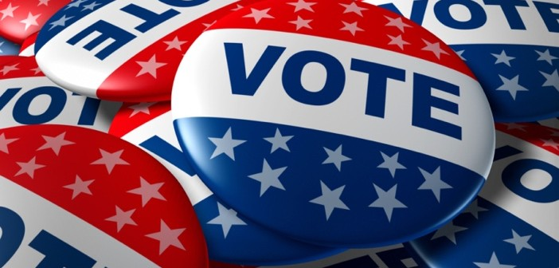

**Reading and Note Taking:** Explaining American Voting Behaviour (Singh p90-101)

*[Type your notes here…]*

**Reading and Note Taking:** Influences on voting behaviour (Fairclough p71-75)

*[Type your notes here…]*

**TASK:** Colour code the groups of voters in the table below to reflect who they tend to vote for. Use blue for likely Democratic voters and red for likely Republican voters.

|  |  |
| --- | --- |
| Southern, white working class males | This group supports this party due, historically, to being a ‘minority group’. This group also has many liberal intellectuals – working in education, the media and the arts – whose views are more closely aligned with this party. However, in recent times their vote has moved a little in the direction of the other party which has been more aggressively supportive of Israel. |
| African Americans | They are seen as more representative of liberal values which tend to be characteristic of the group. They have been directly targeted through effective use of new media and were particularly mobilised by the ‘change’ agenda of the 2008 presidential election. |
| Women | This group has traditionally supported this party because they are a minority group which faces issues such as poverty and immigration. However, their support has fluctuated as the other party has appealed to their predominantly Catholic faith through its anti-abortion stances and traditional family values (anti-gay marriage). This group is also split into different nationalities and do not all necessarily vote the same way. |
| Jews | These areas tend to have more areas of social deprivation where voters are more likely to support the more welfare driven agenda of this party. |
| Hispanic population | The Democrat ‘new deal’ alliance forged in the 1930s began to fall apart during the 1960s with the championing of the civil rights movement and affirmative action. This made this group feel alienated and as though other groups were being prioritised over their interests. They switched loyalty as part of the ‘white backlash’. This group might include soldiers who are committed to patriotic values. |
| Young people | Mostly they will support this party as they have a greater belief in the role of business, lower taxation and less government intervention. However, some of the super-rich from the media will tend to support the other party due to espousing more liberal values and due to the rise of the Christian Right. |
| Wealthy voters | They support this party’s perceived greater support of issues which are seen to be relevant to them. For example, greater welfare intervention to support families and greater support of pro-choice in the abortion debate. Also they are attracted by policies which emphasise greater gun control. |
| Urban voters | This group looks to the government to provide a high quality education for their children, protection from unfair unemployment practices and support through periods of economic or medical misfortune. This party is seen to emphasise this intervention. |
| Rural voters | This group will tend to have more traditional values as, related to the generation in which they were born. They will be less likely to support initiatives for gay marriage and may have grown up in a more racist era. |
| Industrial white working class | This group supports this party’s stance on welfare support, anti-death penalty and their greater support of affirmative action. They have been a strong support for this party since the Civil Rights movement. |
| Religious observers | These areas tend to hold more traditional values in smaller, church going communities. They support the conservative values of this party. Furthermore, farming interests are often better protected by this party. Also they tend to support the right to gun ownership. |
| Older voters | These are the ‘values voters’ who are attracted to the bigger emphasis on God and Christianity within this party. Mostly these voters are protestant and evangelical – less Jewish and Catholic. |

**STRETCH AND CHALLENGE TASK:**

Explore the data the Washington Post has shared…does the data support your analysis above?

<https://www.washingtonpost.com/news/the-fix/wp/2015/04/08/the-10-most-loyal-demographic-groups-for-republicans-and-democrats/?utm_term=.18a0af2b3919>

*[Type your notes here…]*

**EXAM QUESTIONS:**

**Which groups of voters support the Republican Party, and why? (15)**

*Content Guidance:*

Voters typically support the Republican Party because of a mixture of ‘push’ (from the Democrats) and ‘pull’ (to the Republicans) factors. Groups include:

* men – stereotypically divide from women on two clusters of issues: the use of violence, e.g. men are more in favour of gun rights and military solutions abroad; and surrounding the role of government, they favour less activist governments; both views are reflected in Republican values.
* rural voters – attracted by Republican identification with loose environmental protection and support for gun rights • white voters –Southern voters and working-class white voters in particular alienated by the Democratic Party’s identification with minority causes
* elderly voters – recently have turned away from the Democratic Party, apparently in reaction to President Obama, possibly because of scepticism over the health care reforms and budget deficit solutions (see for example http://www.politico.com/news/stories/1110/44802.html )
* business/wealthy voters – attracted by Republican tradition of low tax and business-friendly deregulation
* religious voters – attracted by Republican association with the values of the Christian Right

**TASK:** Which groups voted Democrat in the 2016 elections?

Use this website to help you: <http://edition.cnn.com/election/results/exit-polls>

*[Type your notes here…]*

**Which groups of voters support the Democratic Party, and why? (15)**

*Content Guidance:*

Groups which support the Democratic Party are typically attracted by a mixture of ‘pull’ (towards the Democratic Party) and ‘push’ (away from the Republican Party) factors. The groups which support the Democratic Party include: women – voted Democratic 52-48% in 2010;

* typically women are attracted to Democratic values around activist government, e.g. in promoting health and education provision, and around the use of force, e.g. concerning gun control at home and diplomatic rather than military solutions abroad
* racial and sexual minority voters – attracted by Democratic history and policies on civil rights, affirmative action and immigration, and alienated by the identity of the GOP as the party of the South and the WASP
* union members – voted Democratic 61-37% in 2010; unions have been traditional supporters since the New Deal
* the poor – voters earning under $30,000 voted Democratic 57-40% in 2010, attracted by Democratic policies on welfare and tax
* the young – voters under 30 voted Democratic 55-42% Democratic in 2010, still attracted by the optimism and energy of the Obama campaign in 2008
* elements of the very rich, typically those in Hollywood/media urban/secular voters (figures from Pendulum Swing, Sabato)



**TASK:** Which groups voted Republican in the 2016 elections?

Use this website to help you: <http://edition.cnn.com/election/results/exit-polls>

*[Type your notes here…]*