**‘Congress has become the least powerful branch of government.’ Discuss.**

Examiner Advice

* This was a broad question which allowed candidates to draw on their knowledge of all aspects of the unit 4 specification, and it produced some outstanding answers.
* As was true of all questions, candidates did worst when they made little attempt to adapt what they know to the question and stuck with a plan for an answer to a different question.
* Some for example structured their answer around the functions of Congress, which was not completely unrewardable but became unconvincing by the time they reached representation.
* Others spent most of their time outlining key roles or powers, with little assessment of the extent of power or direct comparison with other branches.
* Again, attention to key words in the question was important; it was common for candidates to see this question as asking, ‘how powerful is Congress?’, concentrating on the constitutional powers, with only limited recognition of the presence of ‘become’ in the question and the concept of change over time.
* A few believed Congress to be just the House of Representatives, with the Senate being discussed as a separate branch.
* Stronger answers showed an assured awareness of the key powers and limits of Congress, and then considered how contemporary developments, such as increased partisanship within Congress, the development of the ‘imperial presidency’ and the increased politicisation of the Supreme Court have affected them.
* The use of recent evidence, such as the verdict in National Federation v Sebelius and the resolution of the fiscal cliff, was particularly effective here, although some candidates perhaps tried to be a little too up to date in their discussion of the revelations of the PRISM program, when they weren’t entirely clear which direction they pointed in.
* A lot of candidates used cases such as Roe and Lawrence to illustrate the power of the Supreme Court, without apparently being aware that in both cases it was not congressional legislation that was being overruled.
* Recent congressional gridlock was used by different candidates both to argue that Congress was and wasn’t the weakest branch, and both cases could be convincingly made.

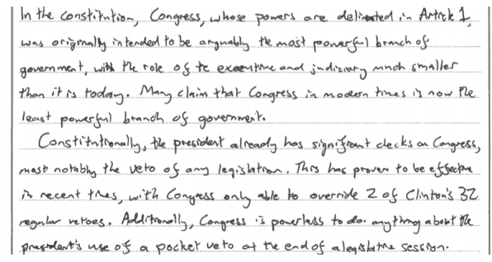

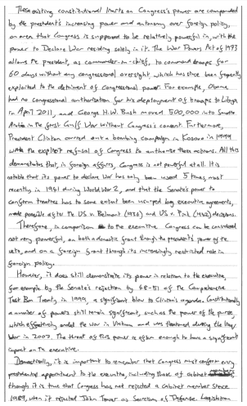

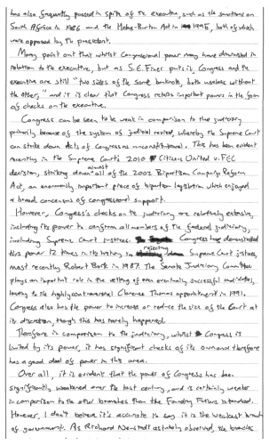



**45 mark Question Generic Mark Scheme**

|  |  |
| --- | --- |
| **AO1** | **Knowledge and Understanding** |
| Level 3  (9-12 marks) | * Full and developed knowledge and understanding of relevant institutions, processes, political concepts, theories or debates |
| Level 2  (5-8 marks) | * Satisfactory knowledge and understanding of relevant institutions, processes, political concepts, theories or debates |
| Level 1  (0-4 marks) | * Poor knowledge and understanding of relevant institutions, processes, political concepts, theories or debates |
| **AO2** | **Intellectual Skills** |
| Level 3  (9-12 marks) | * Good or better ability to analyse and evaluate political information, arguments and explanations |
| Level 2  (5-8 marks) | * Sound ability to analyse and evaluate political information, arguments and explanations |
| Level 1  (0-4 marks) | * Limited ability to analyse and evaluate political information, arguments and explanations |
| **AO2** | **Synoptic Skills** |
| Level 3  (9-12 marks) | * Good or better ability to identify competing viewpoints or perspectives, and clear insight into how they affect the interpretation of political events or issues and shape conclusions |
| Level 2  (5-8 marks) | * Sound ability to identify competing viewpoints or perspectives, and a reliable awareness of how they affect the interpretation of political events or issues and shape conclusions |
| Level 1  (0-4 marks) | * Limited ability to identify competing viewpoints or perspectives, and a little awareness of how they affect the interpretation of political events or issues and shape conclusions |
| **AO3** | **Communication and Coherence** |
| Level 3  (7-9 marks) | * Sophisticated ability to construct and communicate coherent arguments, making good use of appropriate vocabulary |
| Level 2  (4-6 marks) | * Adequate ability to construct and communicate coherent arguments, making some use of appropriate vocabulary |
| Level 1  (0-3 marks) | * Weak ability to construct and communicate coherent arguments, making little or no use of appropriate vocabulary |

|  |  |
| --- | --- |
| **My marks and feedback to this student would be…** | **The examiner’s marks and feedback to this student was…** |